**GLOTIM INTERNATIONAL ACADEMY.**

**FIRST TERM EXAMINATION.**

CLASS: **NURSERY 1 PRAISE**

SUBJECT: **CREATIVE ART.**

1. Trace the apple RED

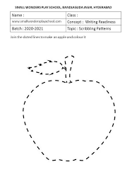

1. Colour the rainbow.

